**PART 1 : FLOWCHART**

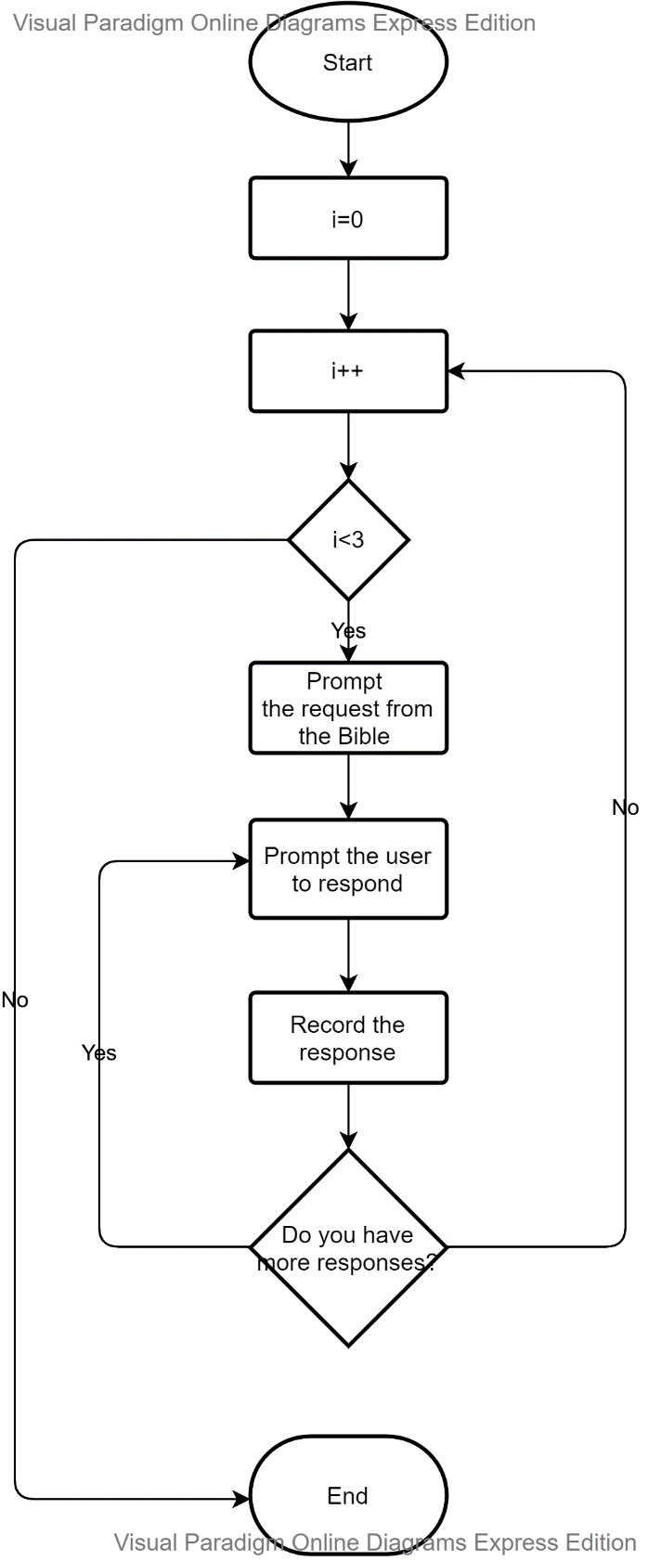

**PART 2 : TEST PLAN C++**

**Code output**

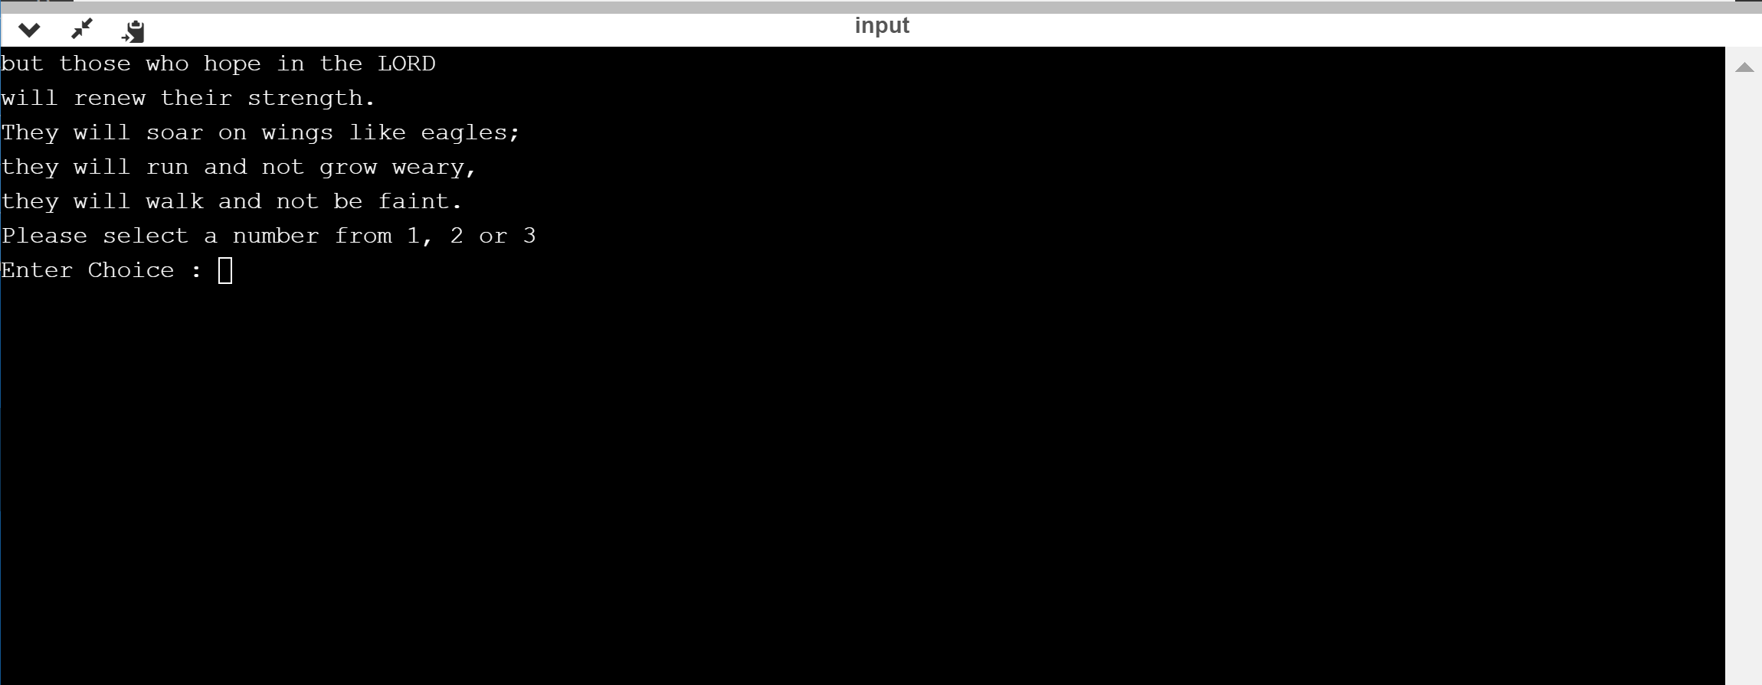

**Enter Choice : 1**

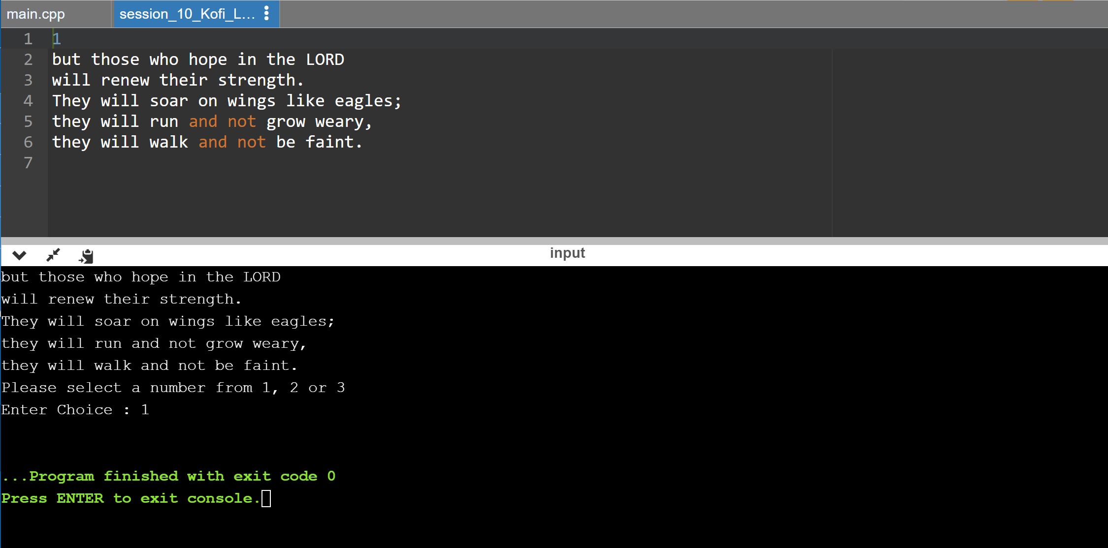

Contents of file

Code output

**Enter Choice : 2**

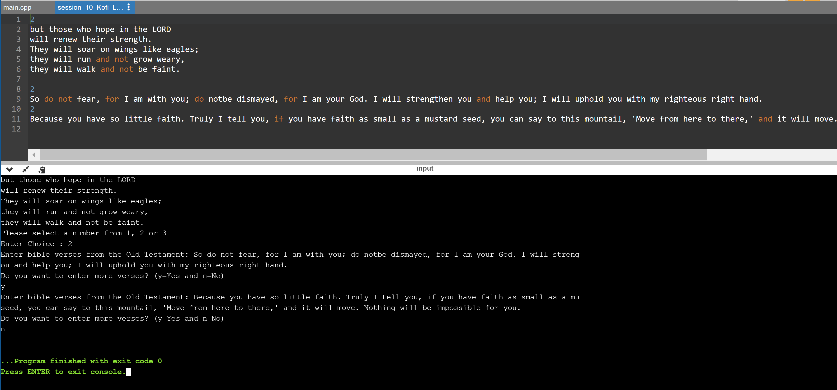

Contents of file

Code output

**Enter Choice : 3**

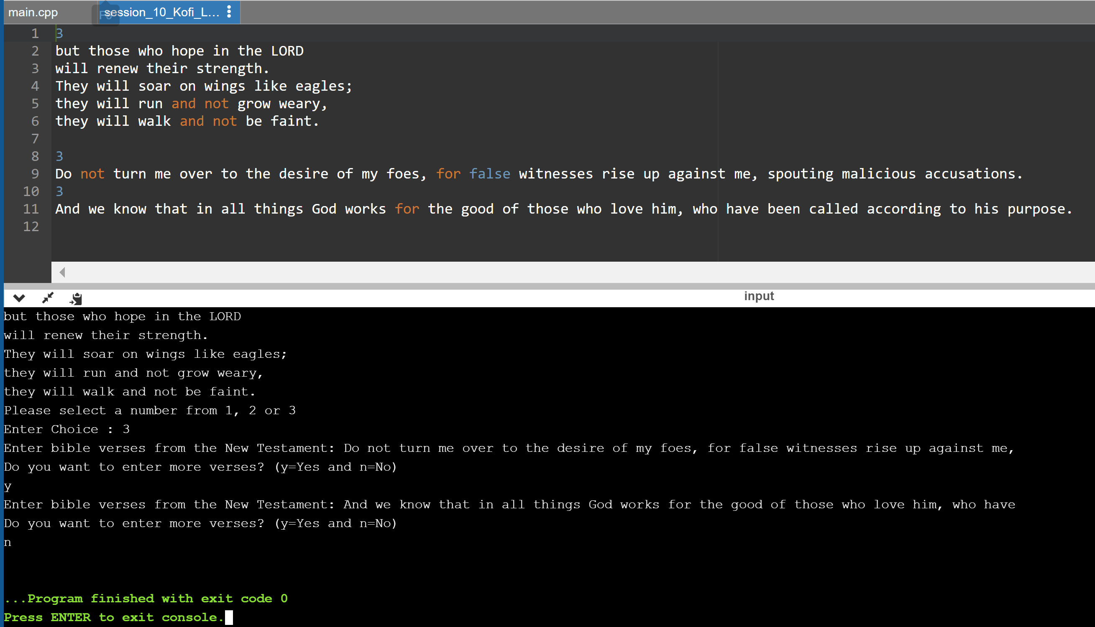

Contents of file

Code output

**PART 2 : TEST PLAN JAVA**

**Code output**

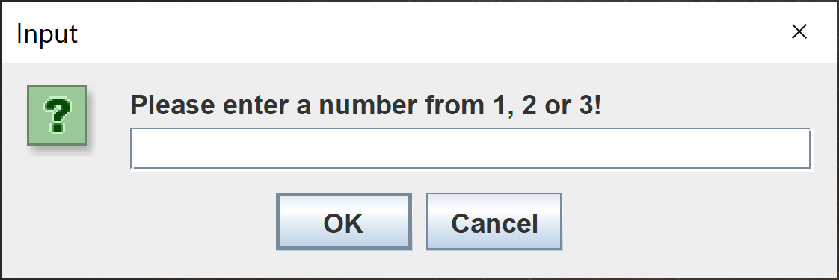

**Enter choice : 1**

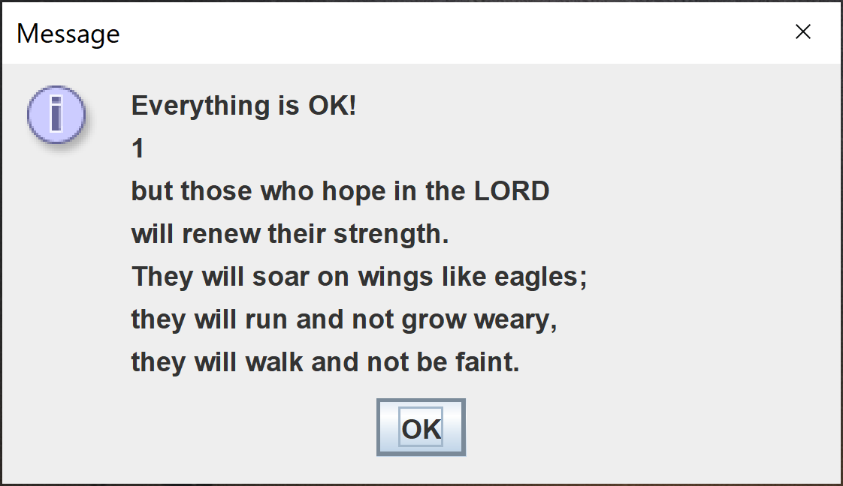

**Enter choice : 2**

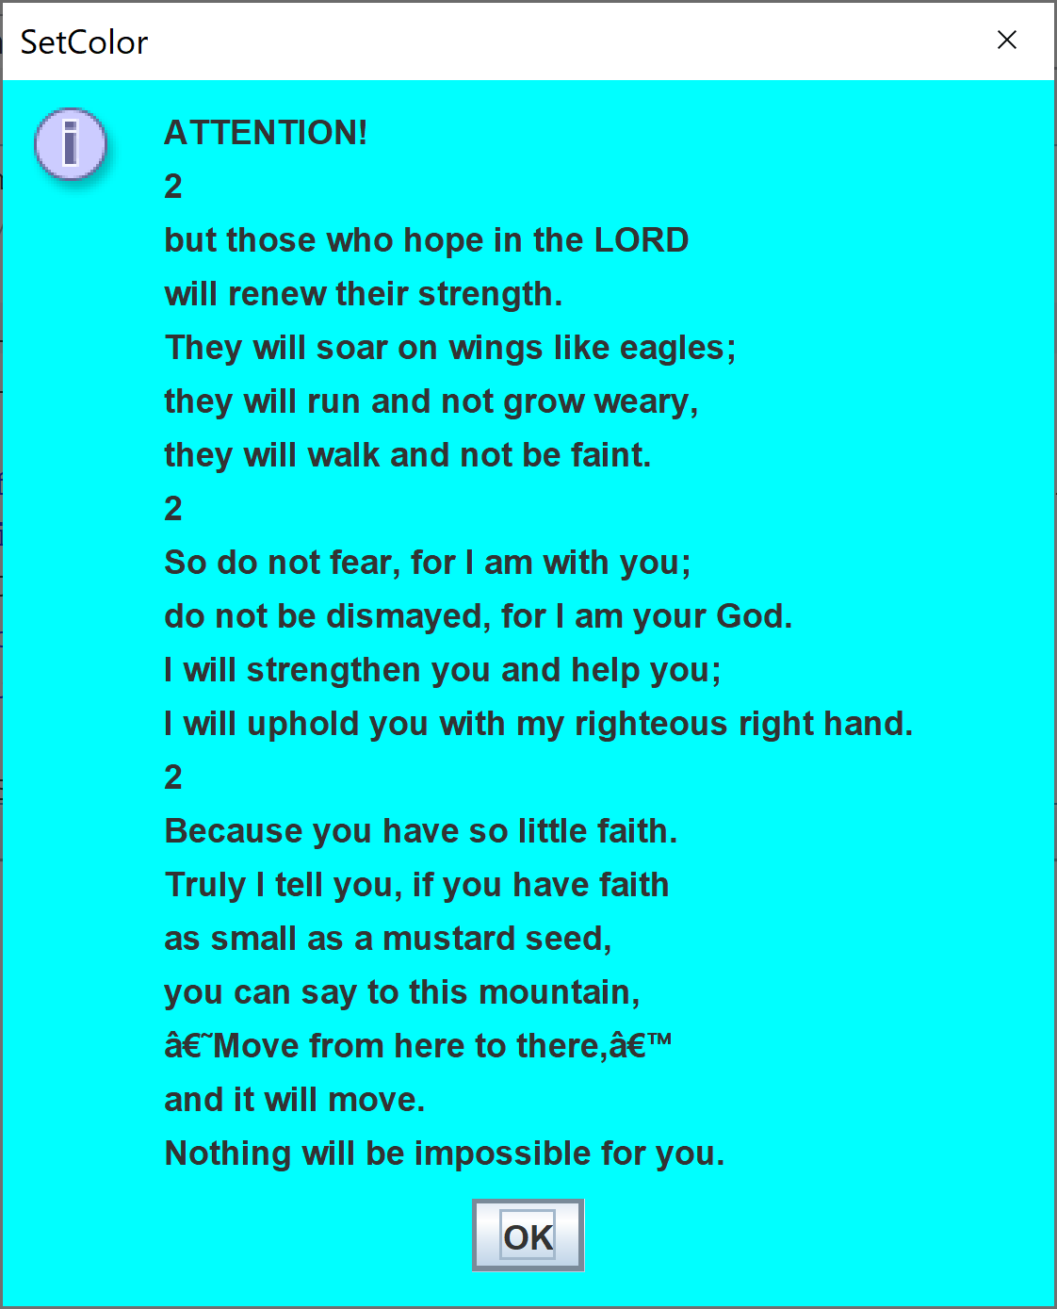

**Enter choice : 3**

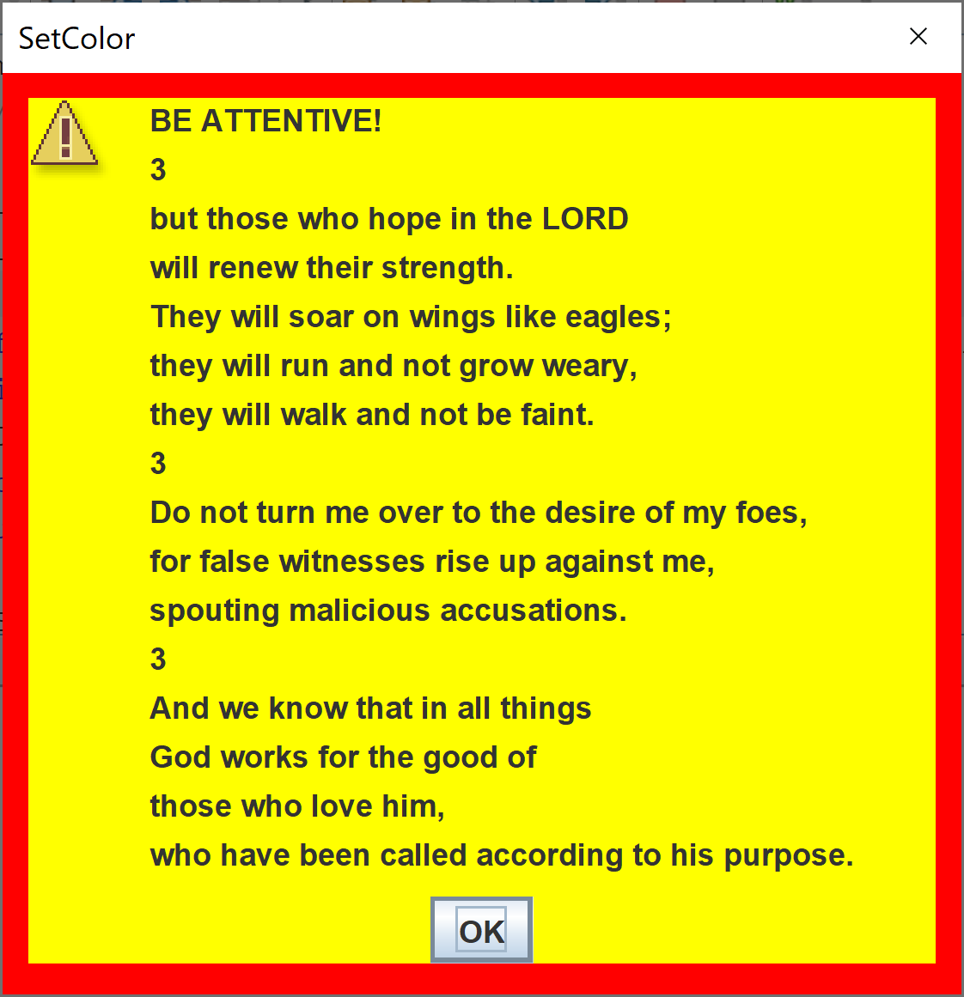

**C++ CODE**

#include <iostream>

#include <fstream>

using namespace std;

int main() {

int choice;

string verse = "but those who hope in the LORD \nwill renew their strength.\nThey will soar on wings like eagles; \nthey will run and not grow weary, \nthey will walk and not be faint.\n";

cout << verse;

cout << "Please select a number from 1, 2 or 3 " << endl;

cout << "Enter Choice : ";

cin >> choice;

ofstream myfile;

char enterVerse = 'y';

switch (choice) {

case 1:

myfile.open ("session_10_Kofi_Larbi_bible1.txt");

myfile << "1\n";

myfile << verse;

myfile.close();

break;

case 2:

myfile.open ("session_10_Kofi_Larbi_bible2.txt");

myfile << "2\n";

myfile << verse +"\n";

while (enterVerse == 'y'){

cout << "Enter bible verses from the Old Testament: ";

string verse2;

cin.ignore();

getline(cin, verse2);

myfile << "2\n";

myfile << verse2 +"\n";

cout << "Do you want to enter more verses? (y=Yes and n=No)\n";

cin >> enterVerse;

}

myfile.close();

break;

case 3:

myfile.open ("session_10_Kofi_Larbi_bible3.txt");

myfile << "3\n";

myfile << verse +"\n";

while (enterVerse == 'y'){

cout << "Enter bible verses from the New Testament: ";

string verse3;

cin.ignore();

getline(cin, verse3);

myfile << "3\n";

myfile << verse3 +"\n";

cout << "Do you want to enter more verses? (y=Yes and n=No)\n";

cin >> enterVerse;

}

myfile.close();

break;

default :

cout << "Invalid choice" << endl;

}

}

**JAVA CODE**

public class session10 {

public static void main(String args[]) throws FileNotFoundException, IOException{

int choice = Integer.parseInt(JOptionPane.showInputDialog("Please enter a number from 1, 2 or 3!"));

File file = new File("session_10_Kofi_Larbi_bible"+choice+".txt");

BufferedReader br = new BufferedReader(new FileReader(file));

String st, fullText = "";

while ((st = br.readLine()) != null){

fullText = fullText + st + "\n";

System.out.println(st);

}

String msg;

switch(choice){

case 1:

msg = "Everything is OK!\n";

JOptionPane.showMessageDialog(null,msg+fullText);

break;

case 2:

msg = "ATTENTION!\n";

UIManager.put("OptionPane.background", Color.cyan);

UIManager.put("Panel.background", Color.cyan);

JOptionPane.showMessageDialog(null,msg+fullText,"SetColor",JOptionPane.INFORMATION_MESSAGE);

break;

case 3:

msg = "BE ATTENTIVE!\n";

UIManager.put("OptionPane.background", Color.RED);

UIManager.put("Panel.background", Color.yellow);

final Runnable SOUND = (Runnable)Toolkit.getDefaultToolkit().getDesktopProperty("win.sound.default");

if(SOUND != null)SOUND.run();

JOptionPane.showMessageDialog(null,msg+fullText,"SetColor",JOptionPane.WARNING_MESSAGE);

break;

default:

System.out.println("Invalid choice");

break;

}

}

}